Line graph tips:
Use reference line to support comparison over time effectively
Can also use reference band e.g. confidence interval/quantile range instead of reference line
Label individual lines in a graph with multiple lines rather than using a legend

For time series version of data package
Tidyverts tidyverse
Tsibble tibble data frame
Feasts feature extraction
Fable tidy forecasting

Timetk time series analysis
Modeltime forecasting
Modeltime H20 (AutoML), Modeltime Gluon 15 (Deep Learning)
https://business-science.github.io/modeltime/

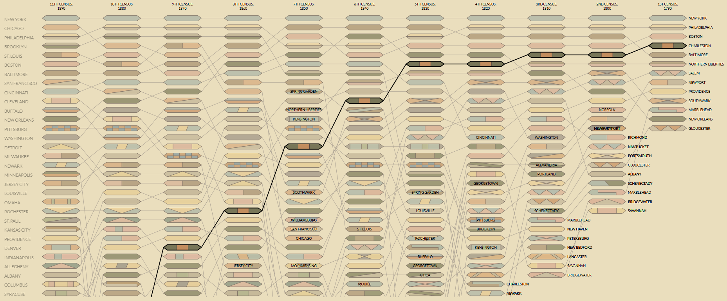
Bump plot, does not show rate of change like a slopegraph can
Link: https://vallandingham.me/census_bump/

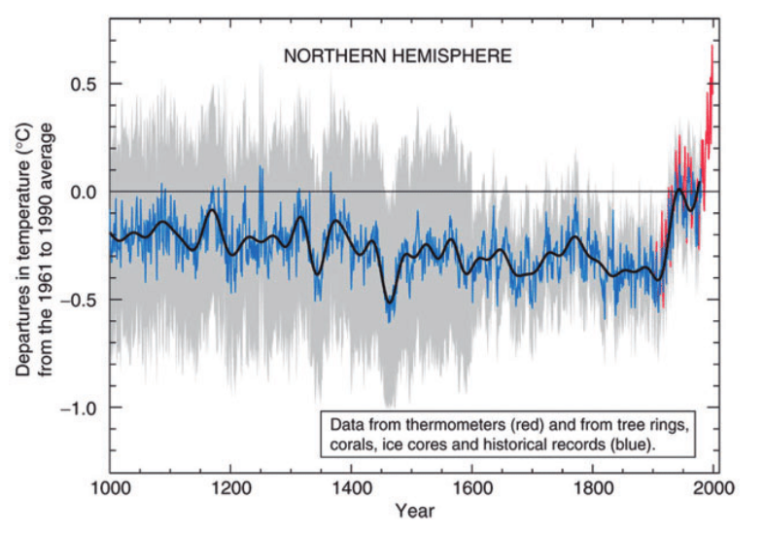
Grey part is the variability, can see there is more variability in the beginning while the ending not so much, which means it is a definite increase in temperature vs the beginning where the temperature varies a lot and the trend cannot be explicitly determined.

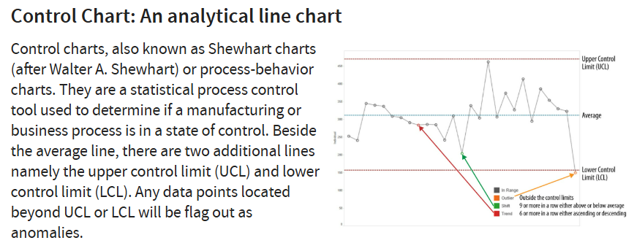

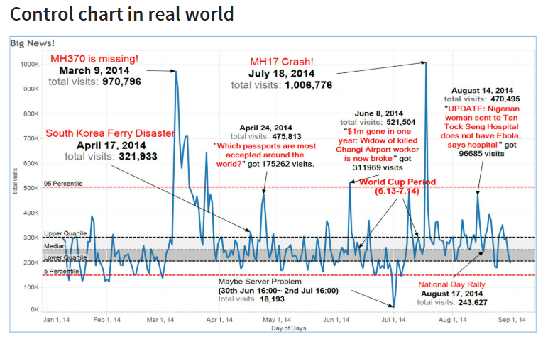

Useful to flag out anomalies

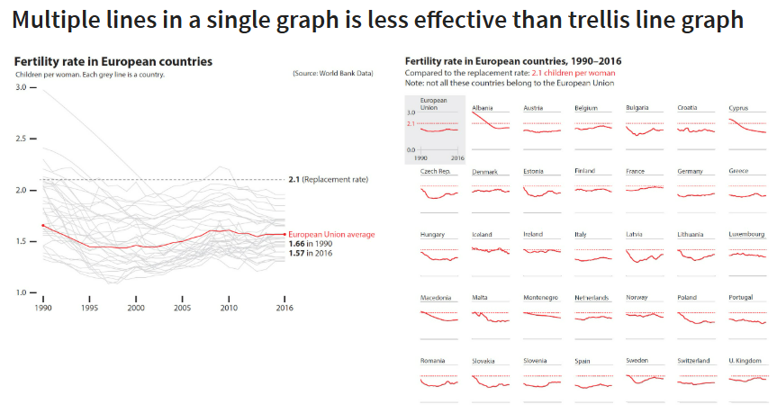
Use facet grid in ggplot2 package

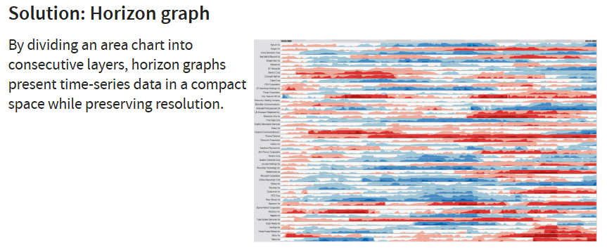
Darker red means more negative, darker blue means more positive

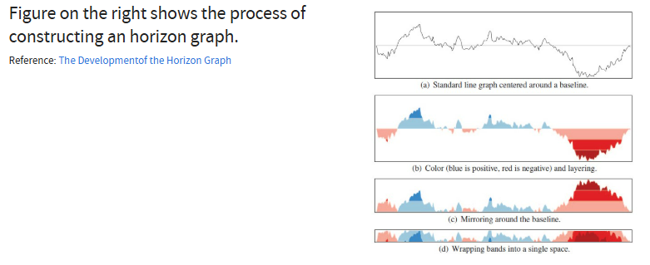
Can make it interactive using gganimate and ggiraph

